|  |  |  |  |
| --- | --- | --- | --- |
| State | ATM Process | Input result | Output Result |
|  |  |  |  |
| S1 | Card details | Pass | Pass |
| S2 | Invalid card | Fail | Fail |
| S3 | Valid Pin | Pass | Pass |
| S4 | Invalid pin | Fail | Fail |
| S5 | Amount withdraw | Pass | Pass |
|  |  |  |  |
| S6 | Insufficient amount | Fail | Fail |

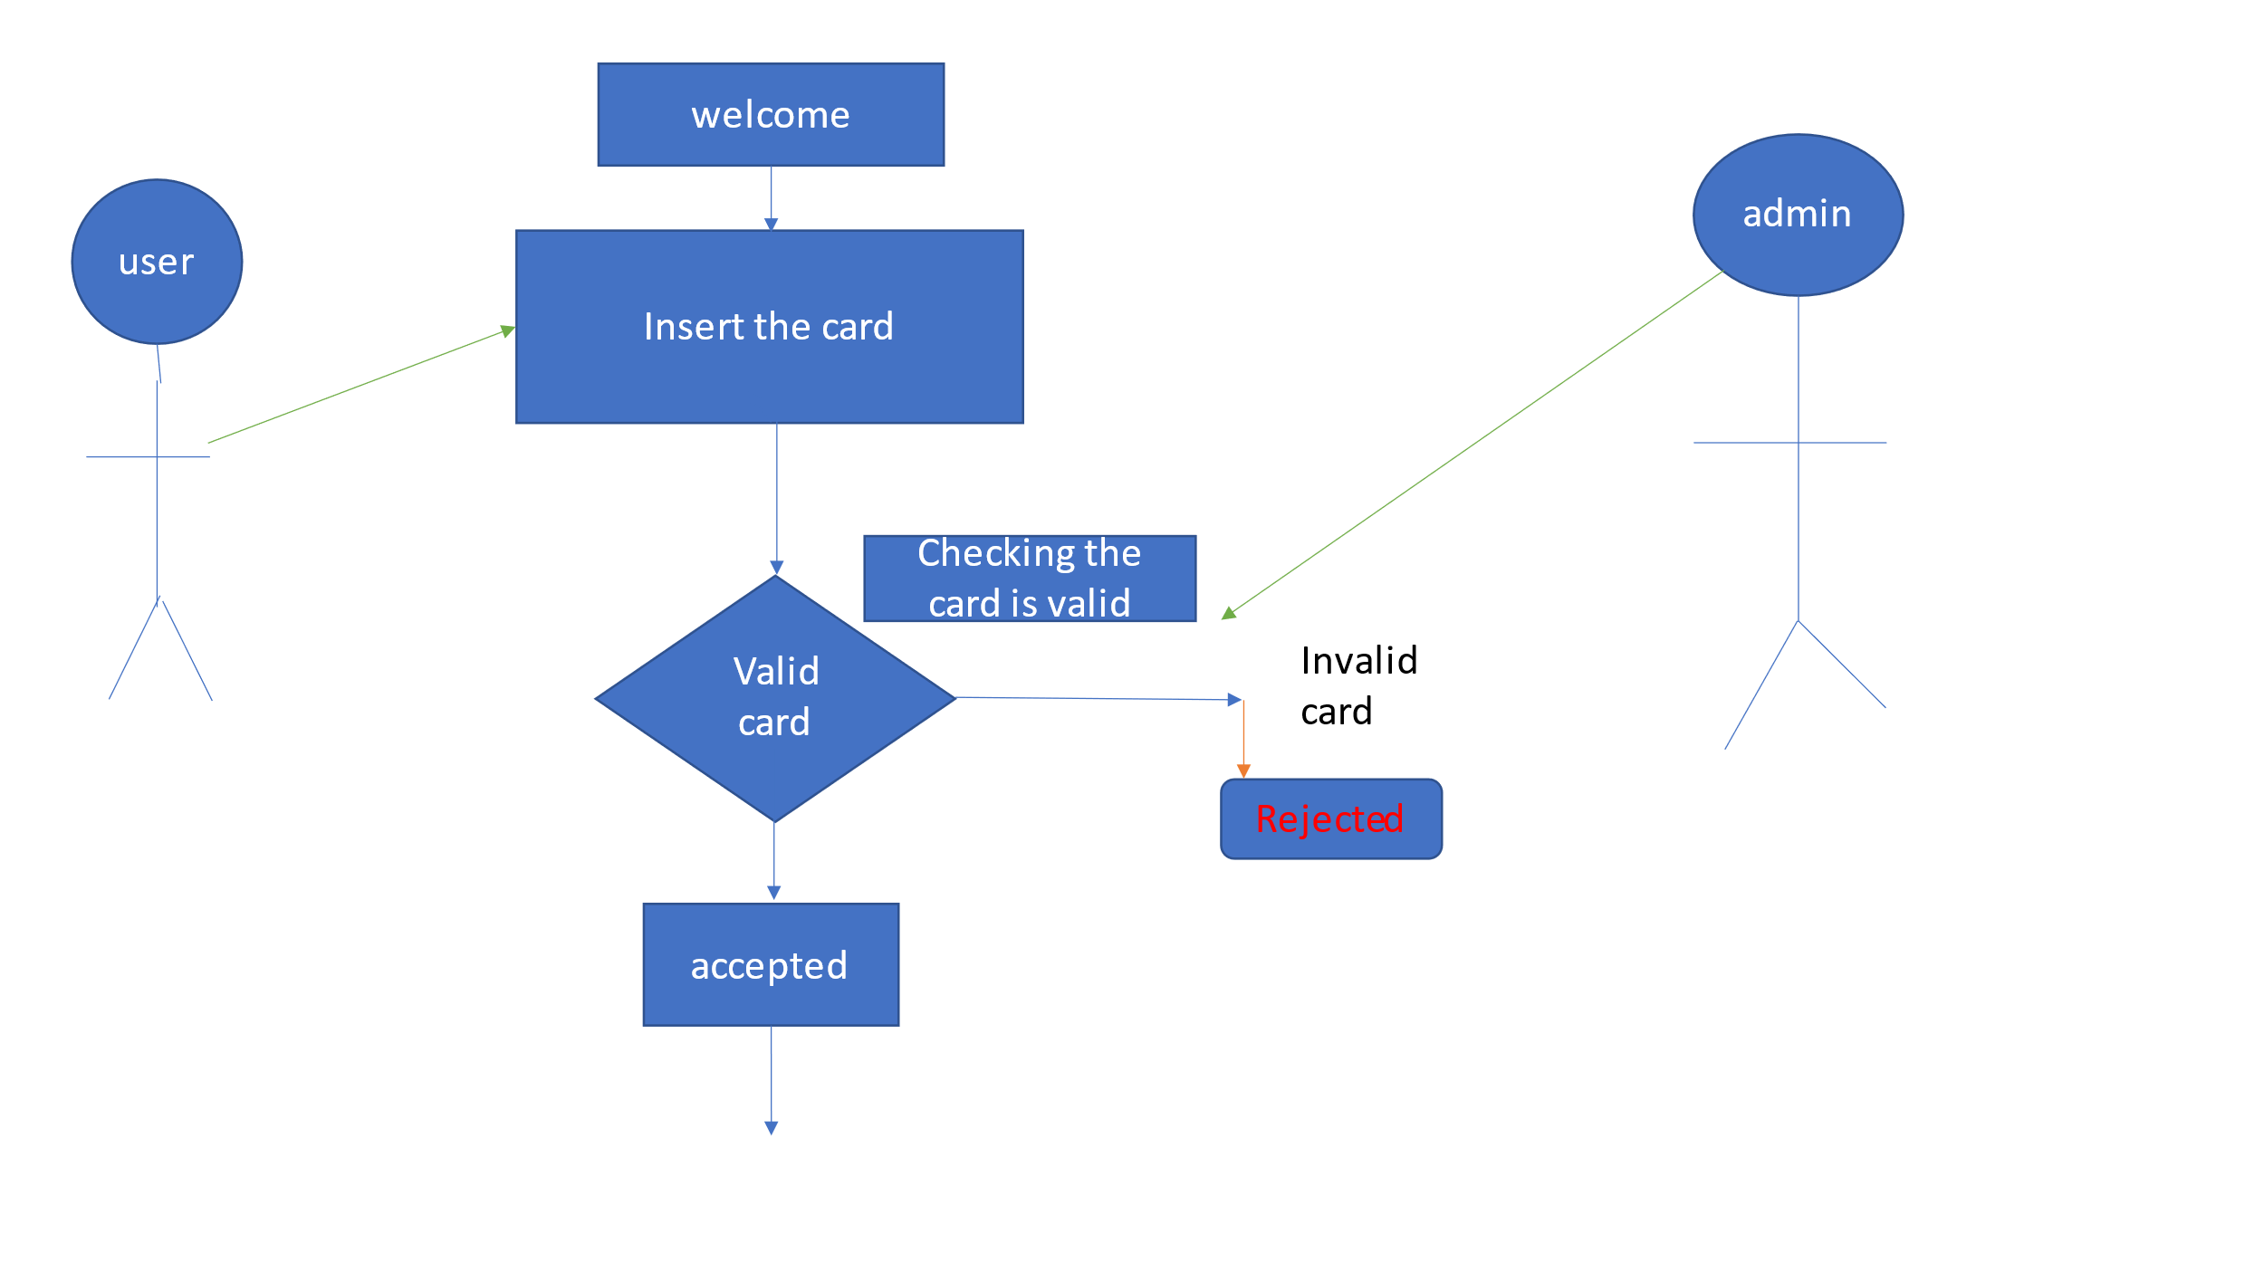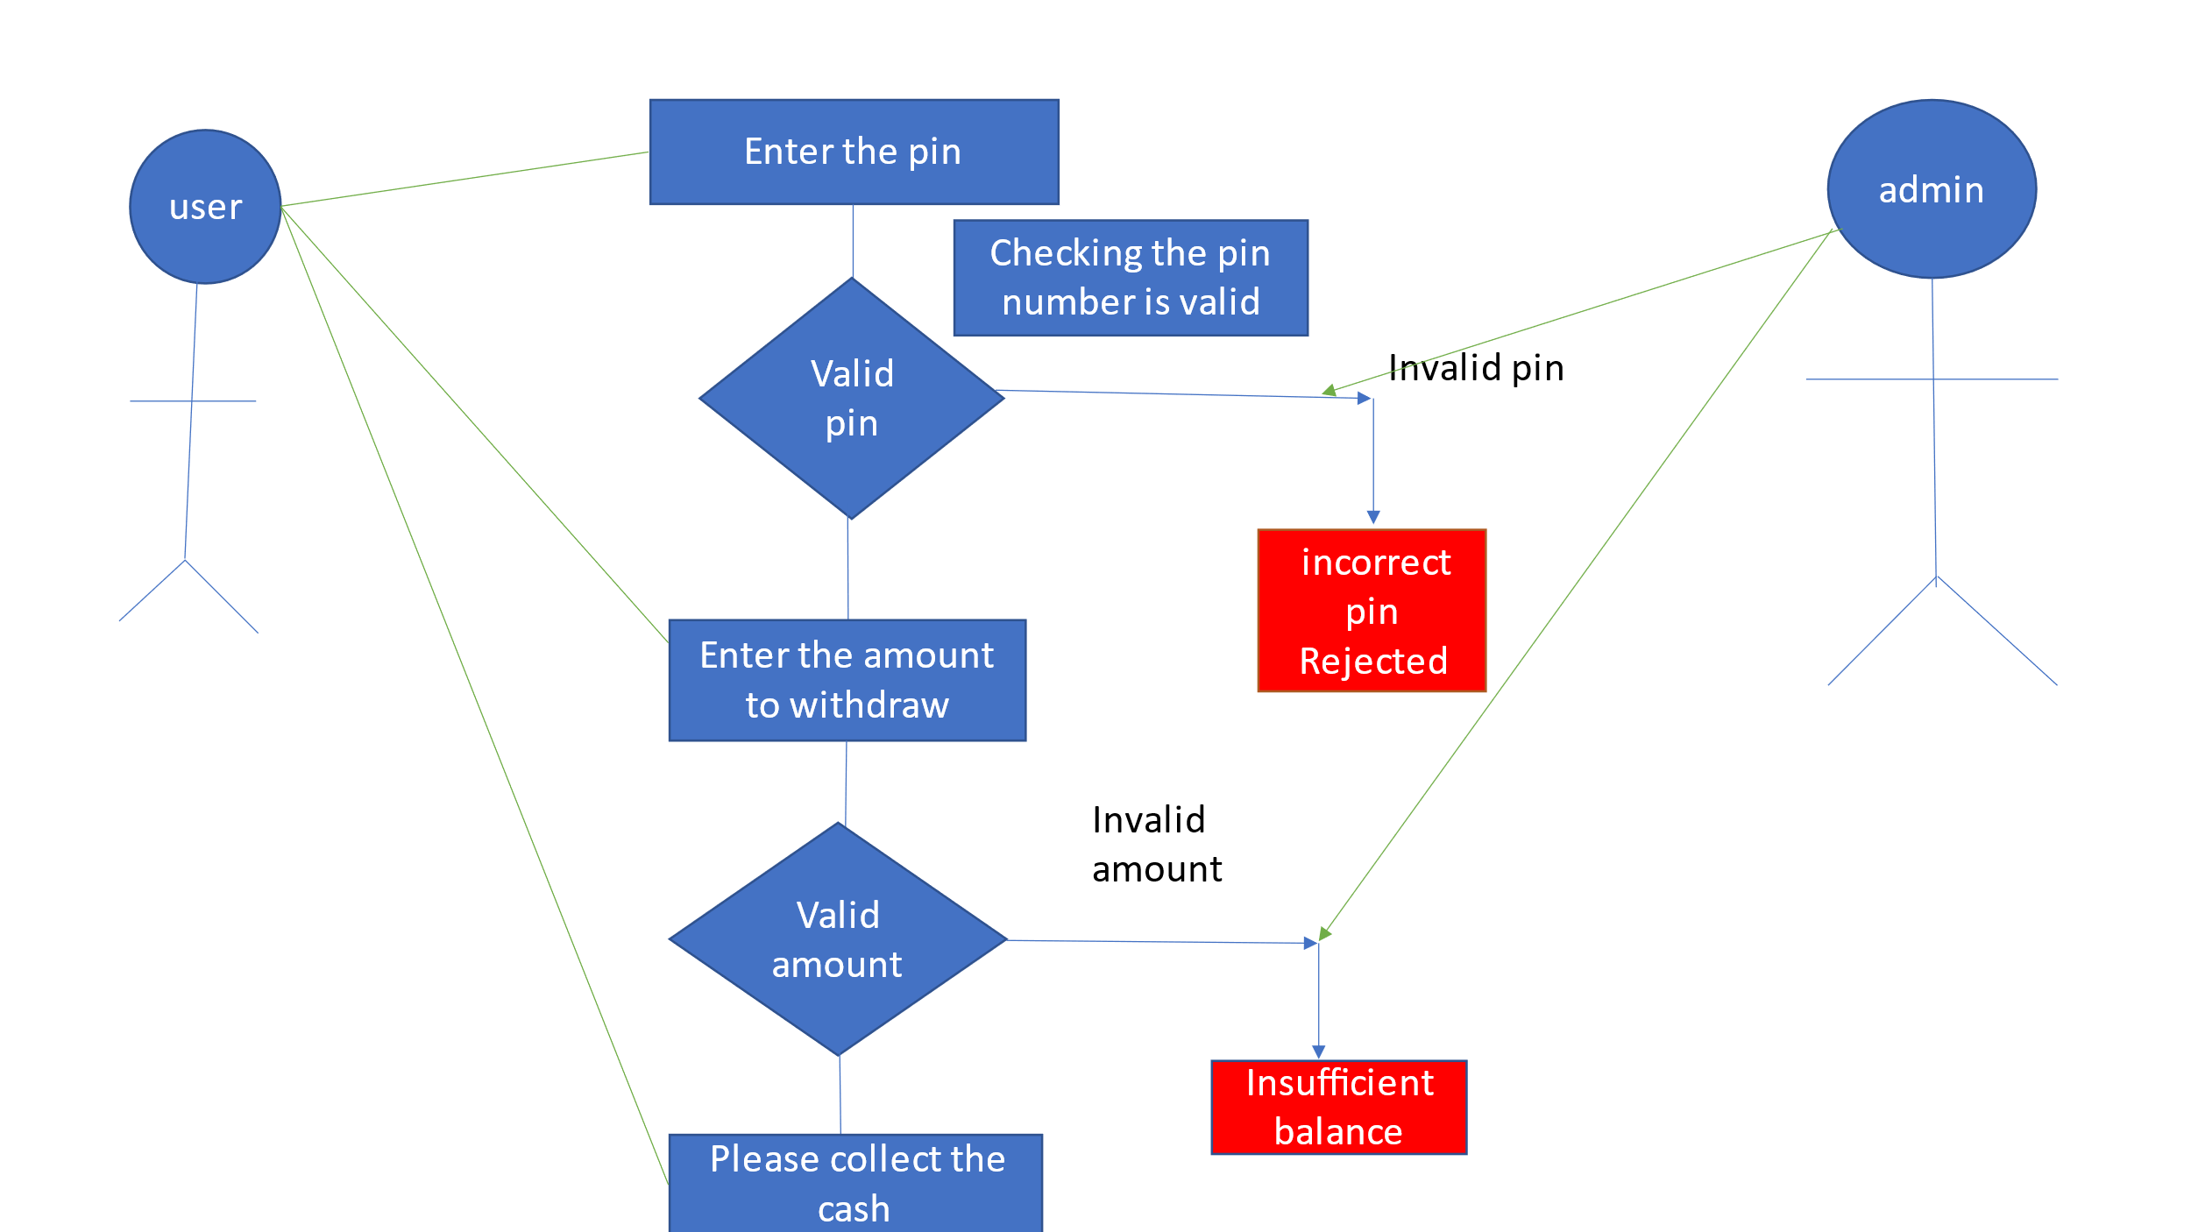

Basic Flow

B1: Valid card

B2: Valid pin

B3: Valid Amount

B4: Withdraw successfully

Alternative Flow

F1: Invalid card

F2: Invalid pin

F3: Invalid amount(Insufficient balance)